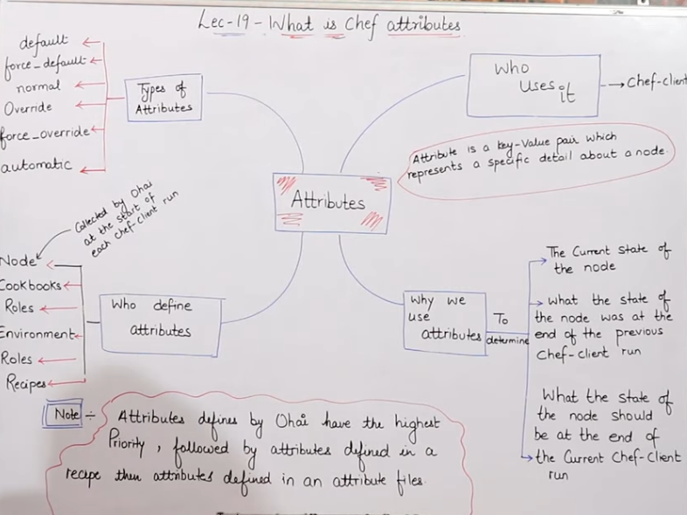

CODE USED IN THIS LAB\*\*\*\* file '/basicinfo' do content "This is to get Attributes HOSTNAME: #{node['hostname']} IPADDRESS: #{node['ipaddress']} CPU: #{node['cpu']['0']['mhz']} MEMORY: #{node['memory']['total']}" owner 'root' group 'root' action :create end

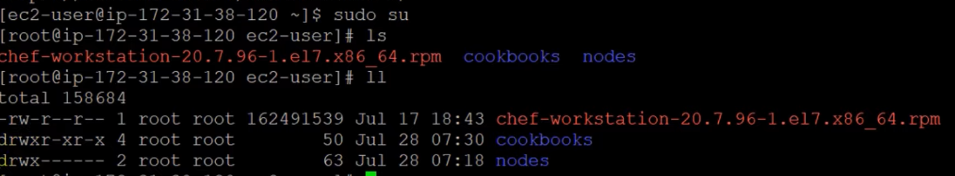

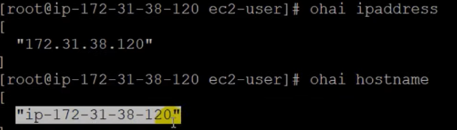



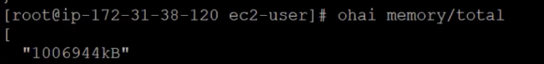

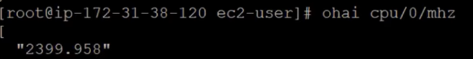

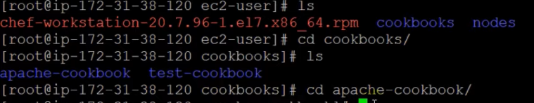

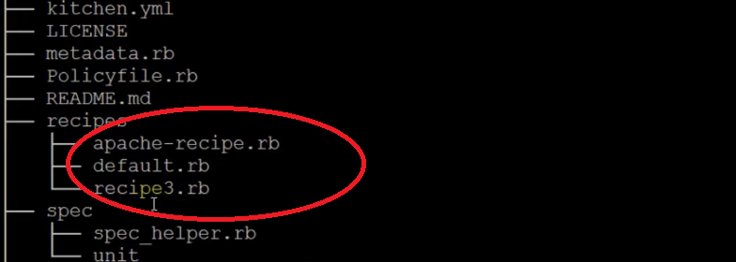

New recipe



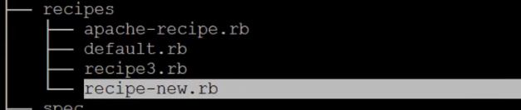



Code

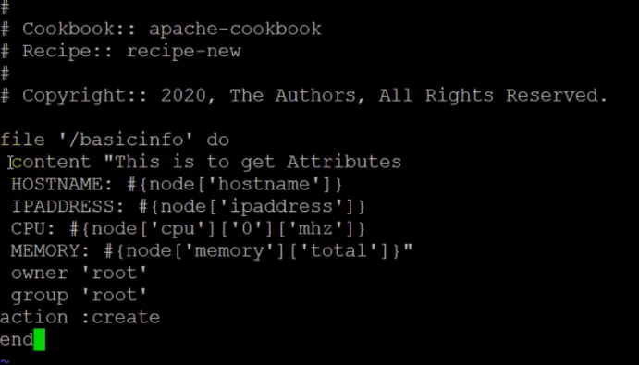



Output on the code

